**Day 5 - AWS - ELB, ASG, Cloud watch, SNS & SQS**

**auto scaling group ,It intelligently analyses the request. Based on that, it will scale up. It will increase the Count of Ec2 or decrease the Count of Ec2 in a Aws account. mainly we go for this auto scaling group to** **automatically scale up and scale down so that you can, you can cut down on your cost.**

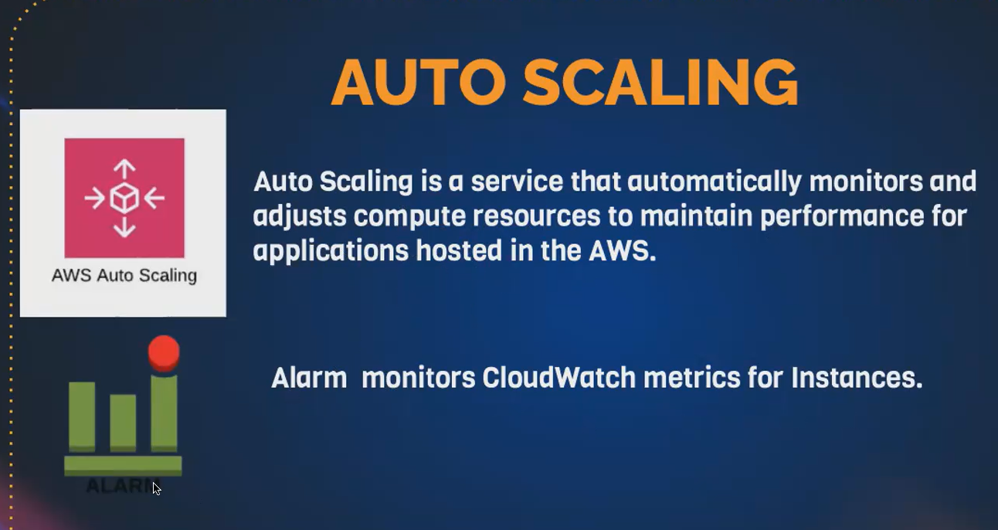

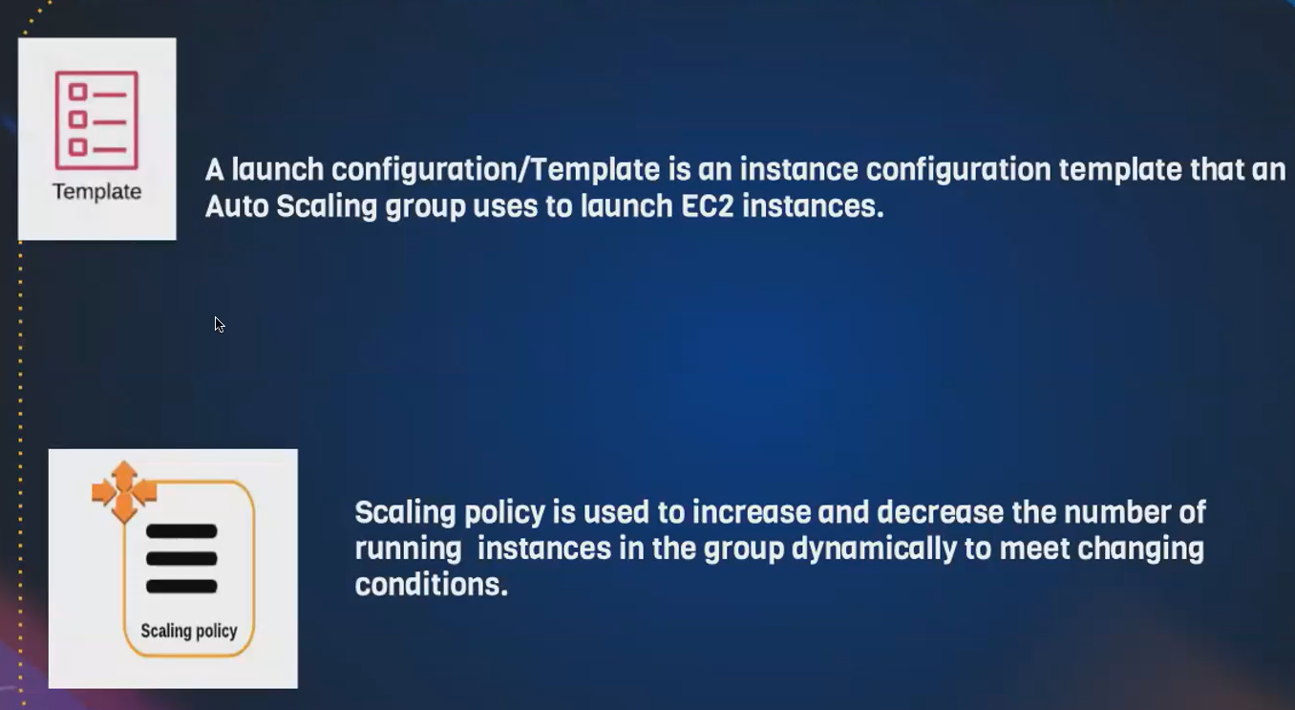

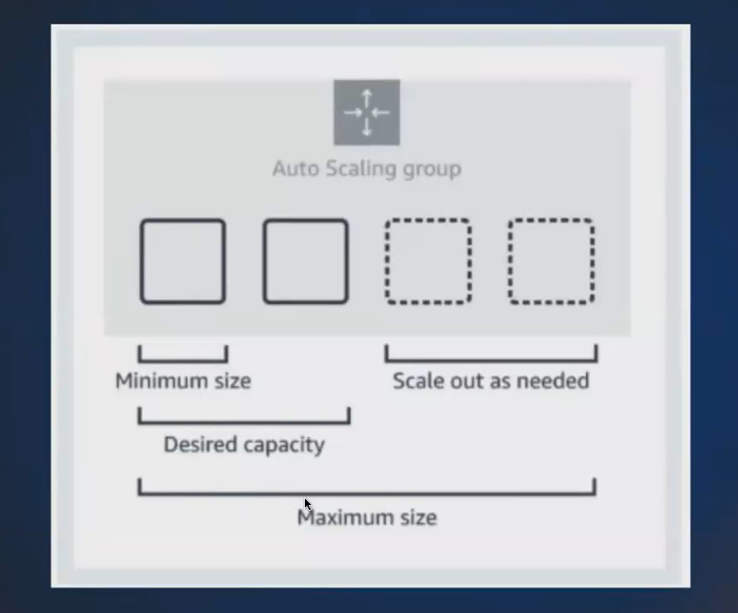

* **maximum capacity means, if I have to scale up so it will scale up till my maximum size.**
* **So if I give 4, your auto scaling group can only create up to 4 Ec2 do not go beyond that.**
* **if I have to scale down it will scale down to the desired capacity.**
* **our auto scaling group will maintain minimum of 2 ec2 always.**

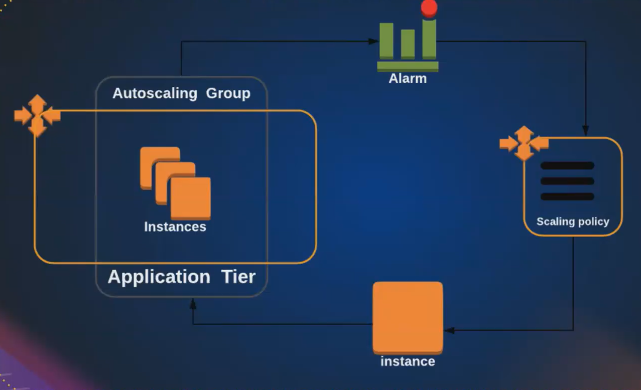

**This service comes under ec2 instance:**

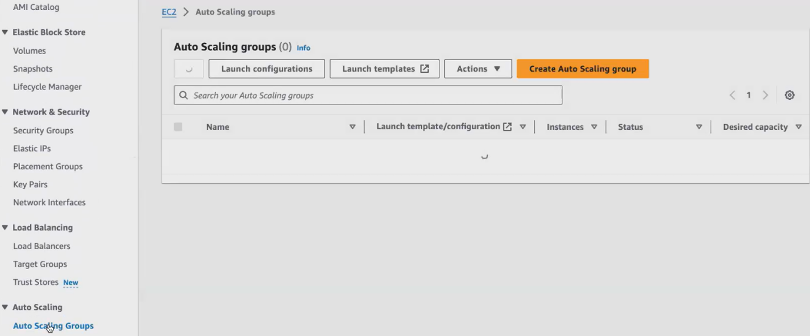

**Before creating auto scaling group , create a launch template**

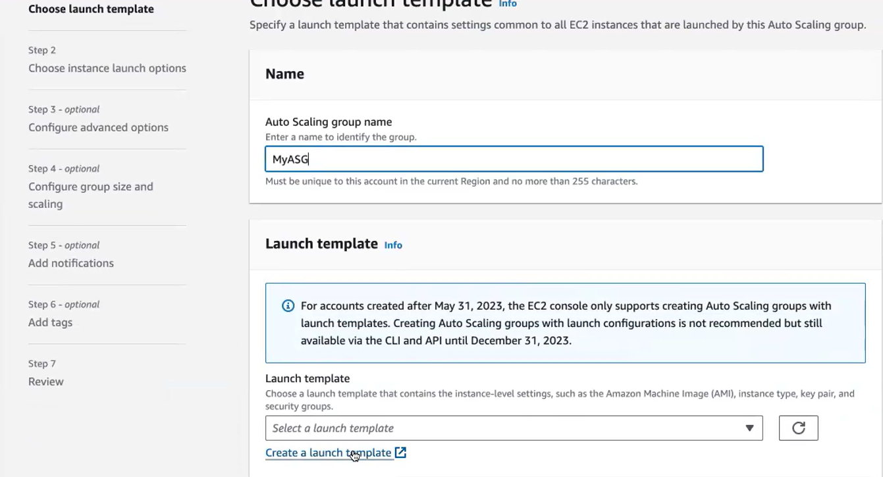



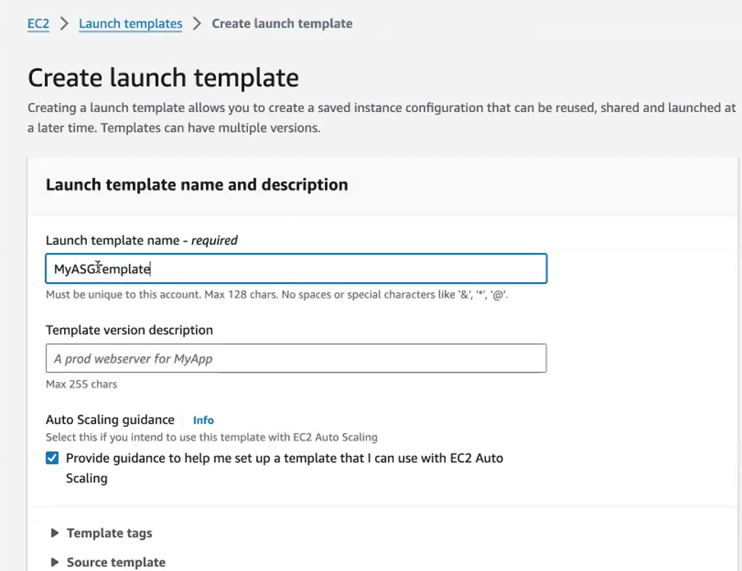

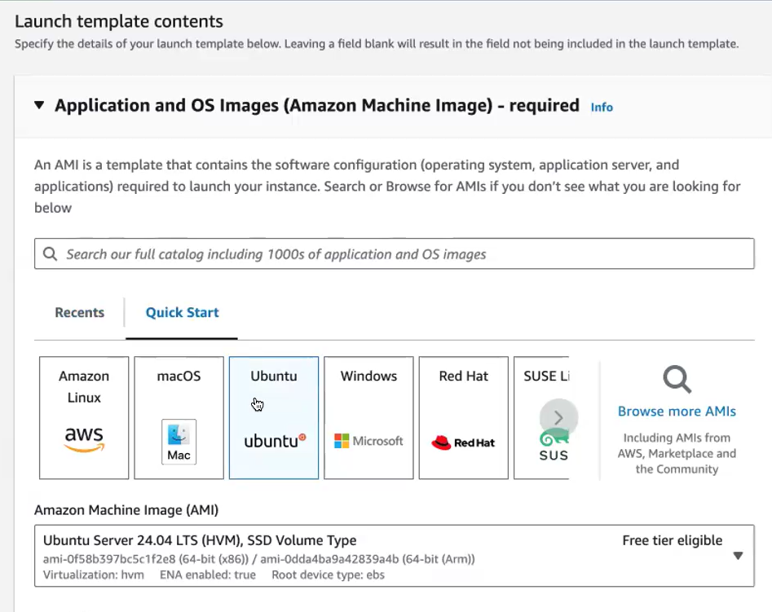

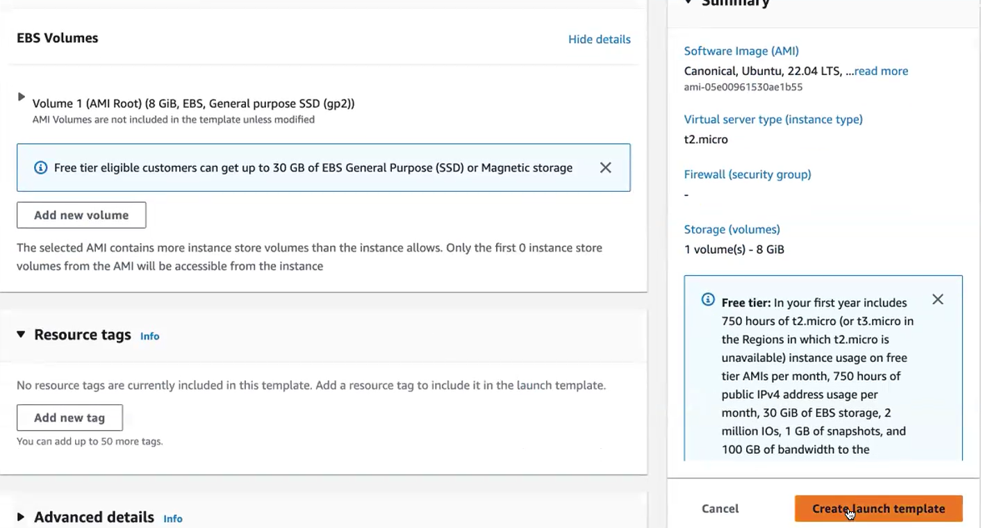

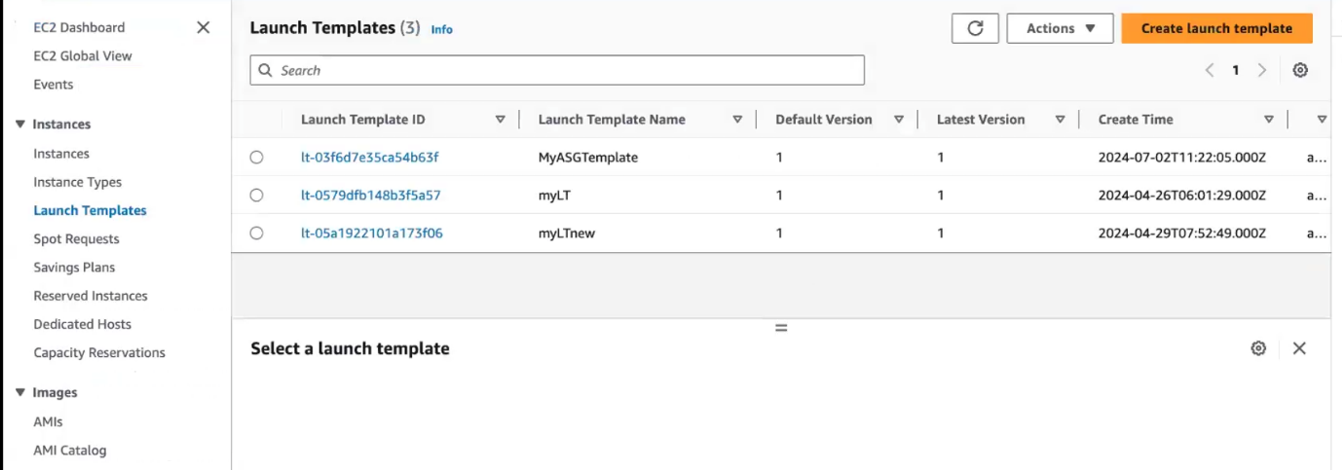

**Template created. Again go to auto scaling option.here select our template name**

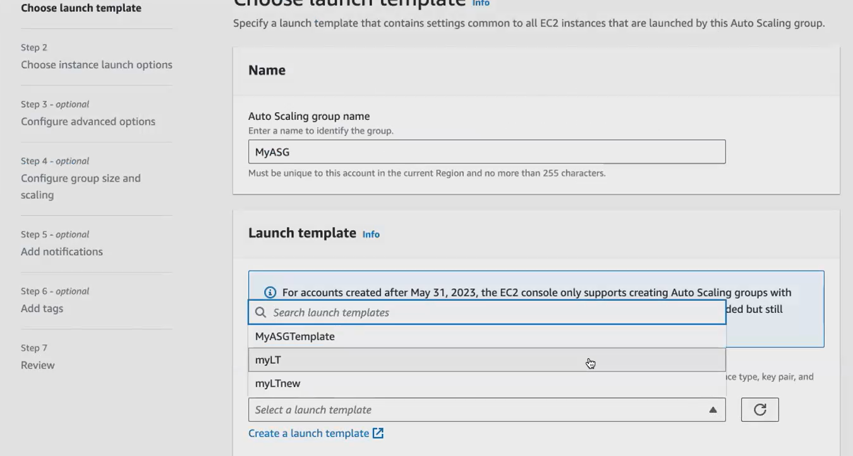

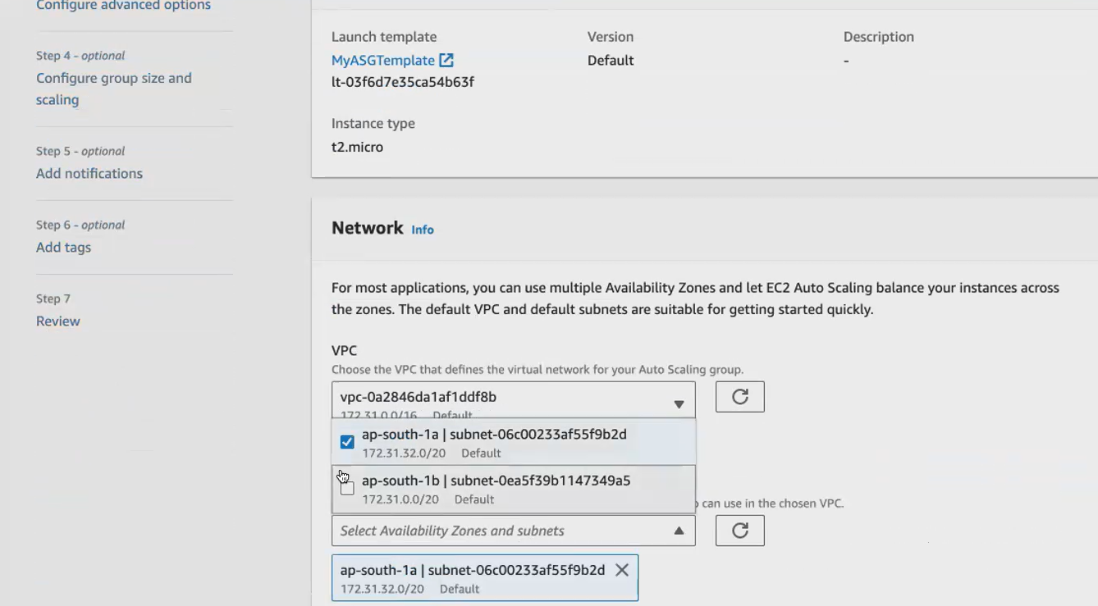**ec2 create default vpc..select 2 a.z**

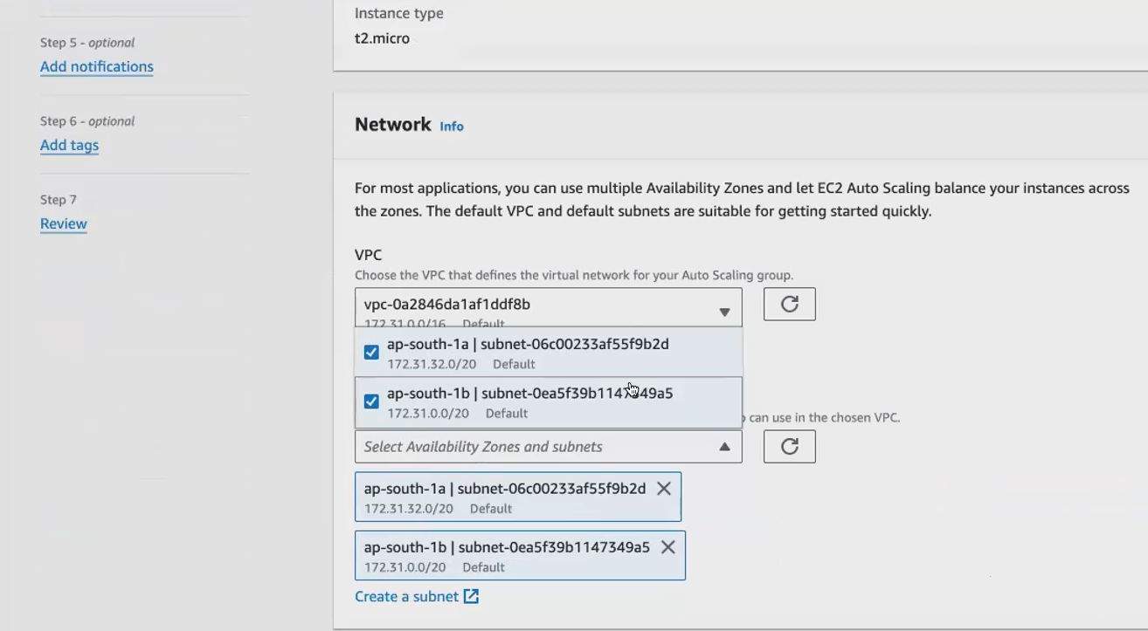

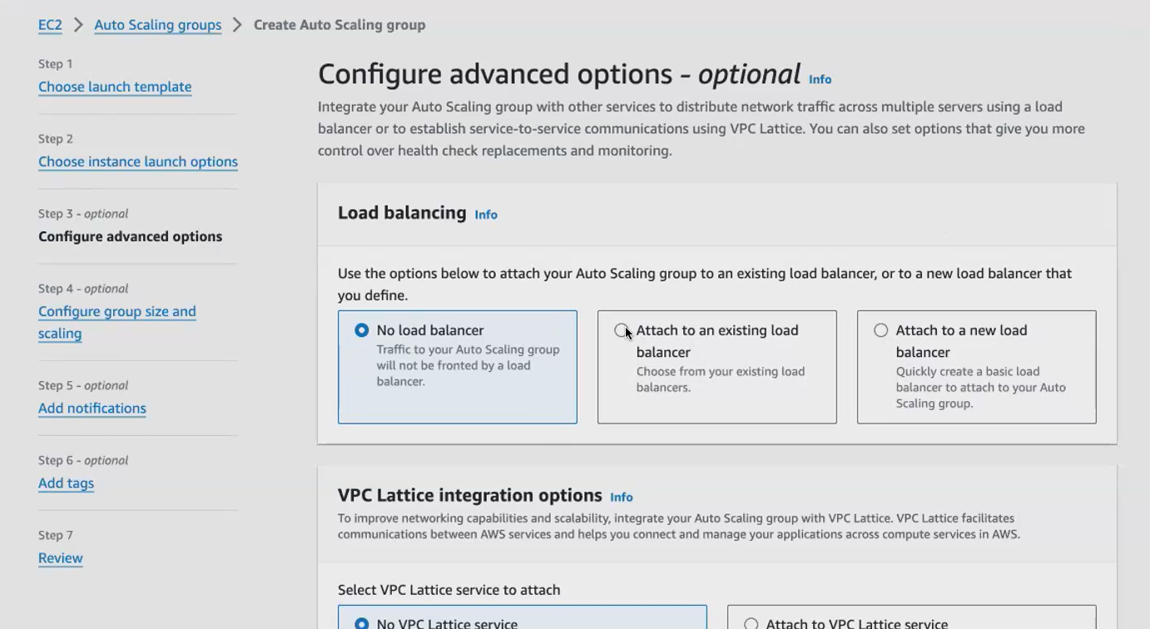

**If we want load balance attach it here.we don’t need**

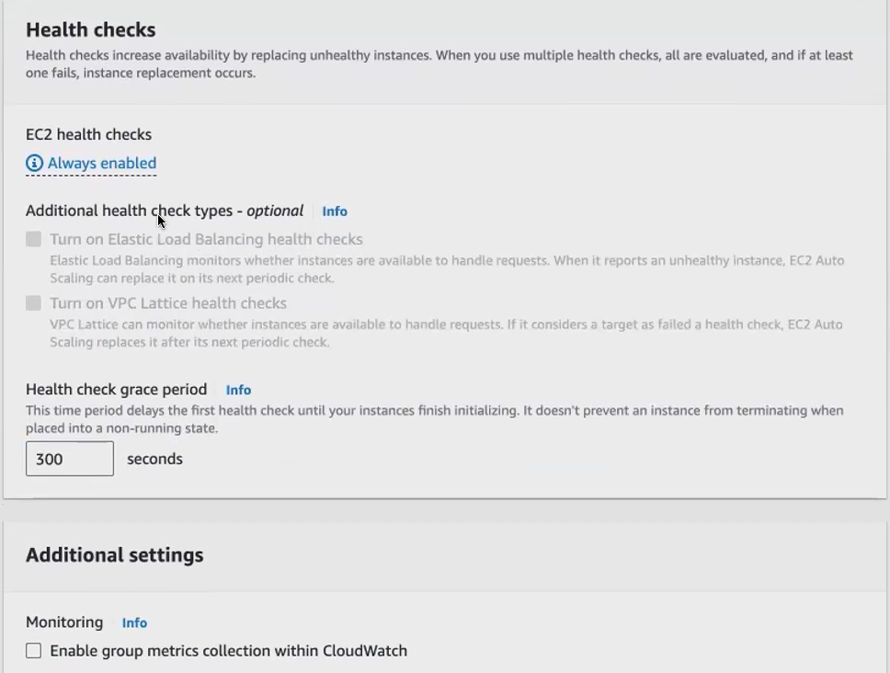**why health check? Suppose del instance ,it again regain it.so it is always enable**

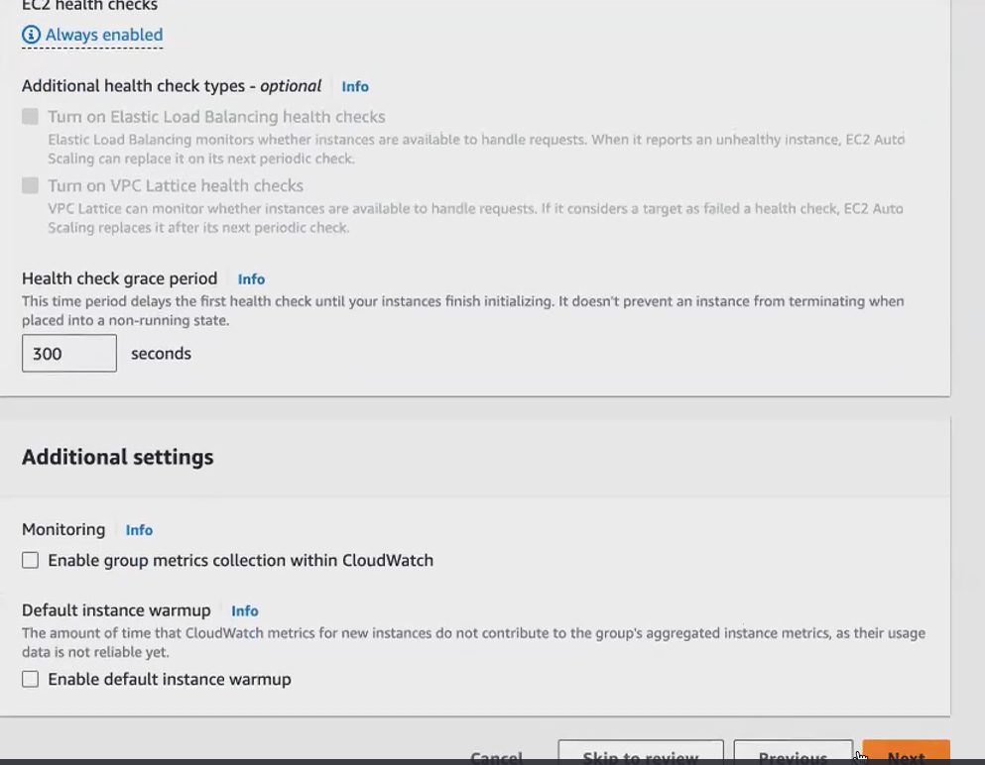

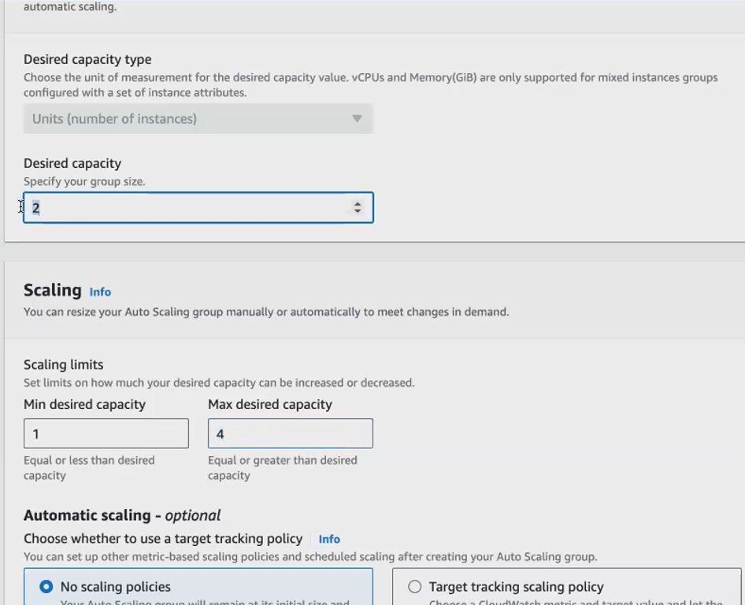

**Always D.C IS 2 ..MIN AND max our choose**

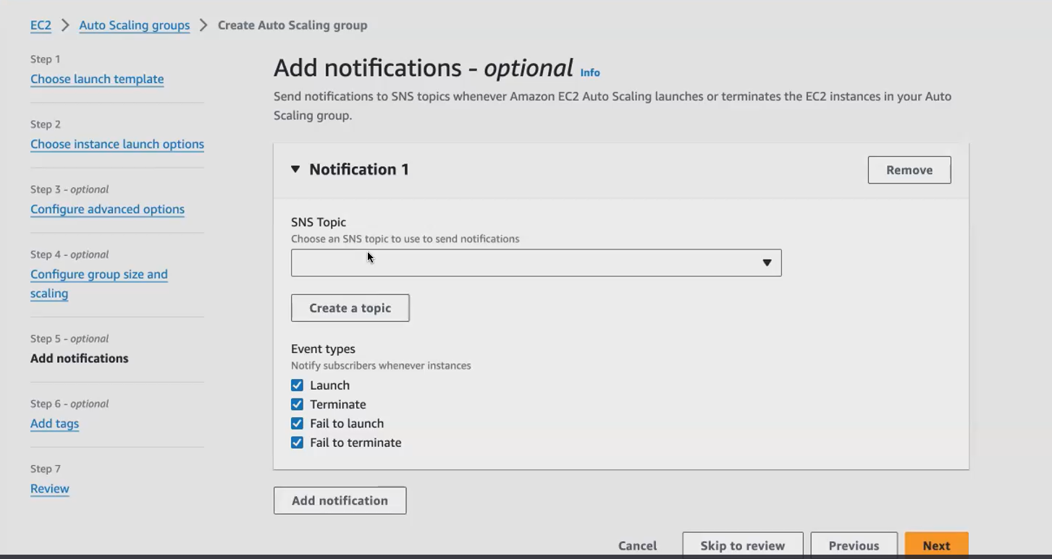

**if you want, you can also add notification. So this will. This will create a notification. Notification means if any. If as I told you, your auto scaling group will be connected with your cloud watch, monitoring tool cloud watch is a monitoring tool. We will be covering up. And this monitor, this auto scaling group, will send you a notification.**

**or what will happen it will, you can tell you. Can you can trigger a event. So if anyone easy to mission goes down so I can. I can tell my auto scaling group to launch a new one terminate the old one.**

**whenever there is a change happening in my auto scaling group. I wanted to be notified. If I wanted to be notified. I can create a topic here. Topic means so since we don't. We haven't created any Sns topic, SNS means simple notification service and aws, which helps you to send the notification via email.**

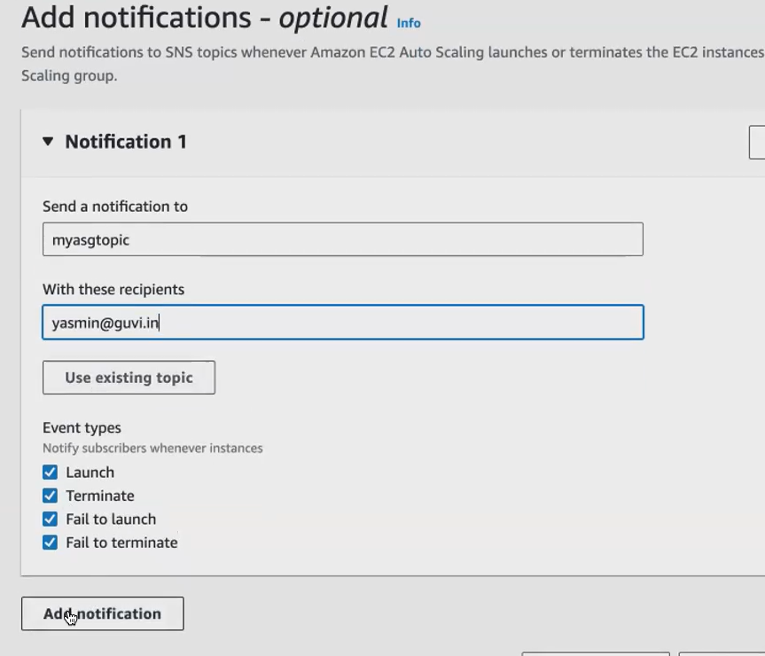

**Add tags nothing has change Click create auto scale .as is created**

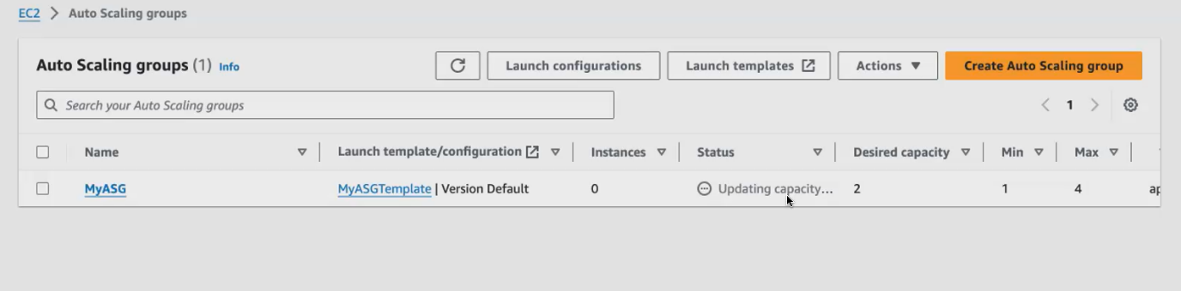

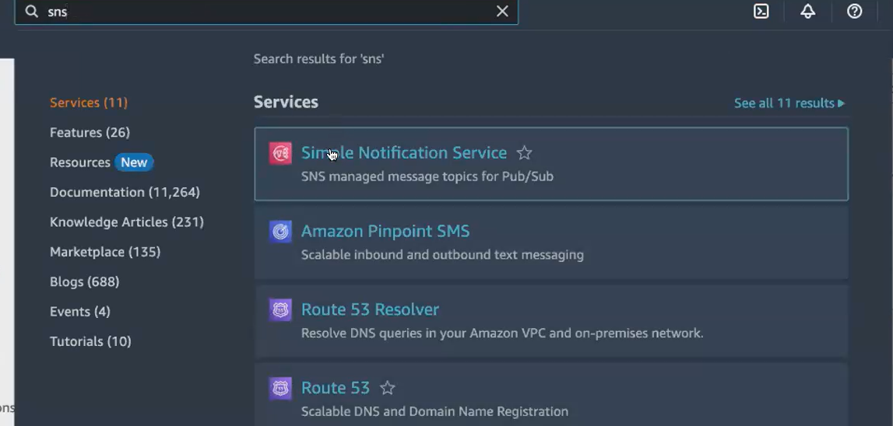

**Check SNS is send notification or not**

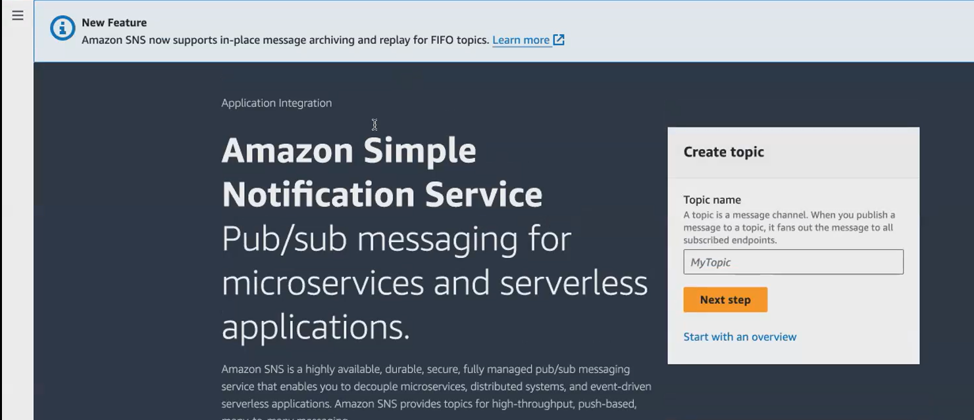

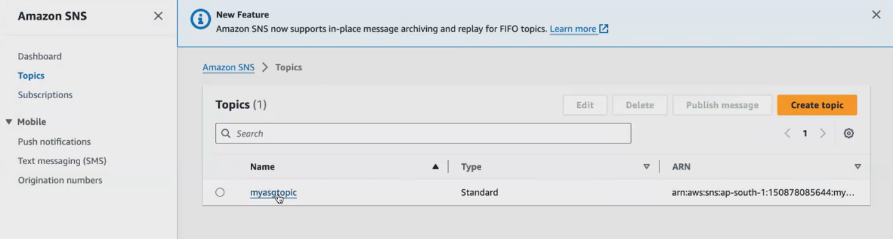

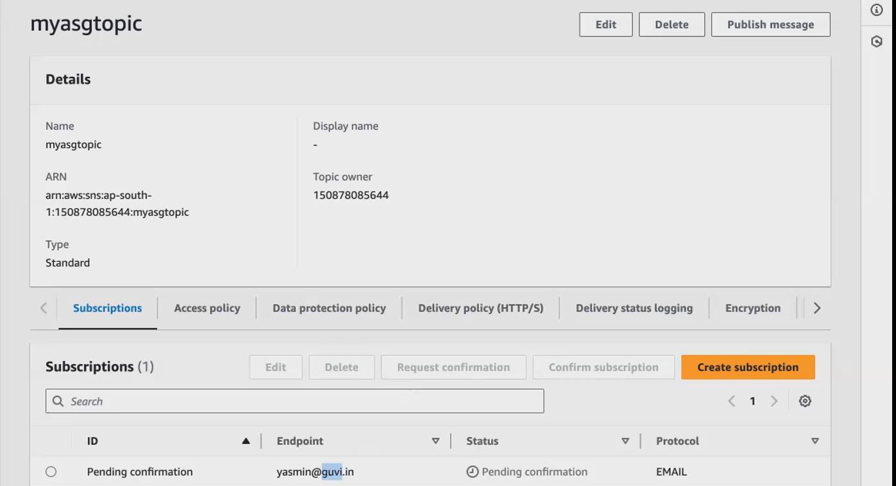

**Not confirmed still is bending..goto our mail give confirmation**

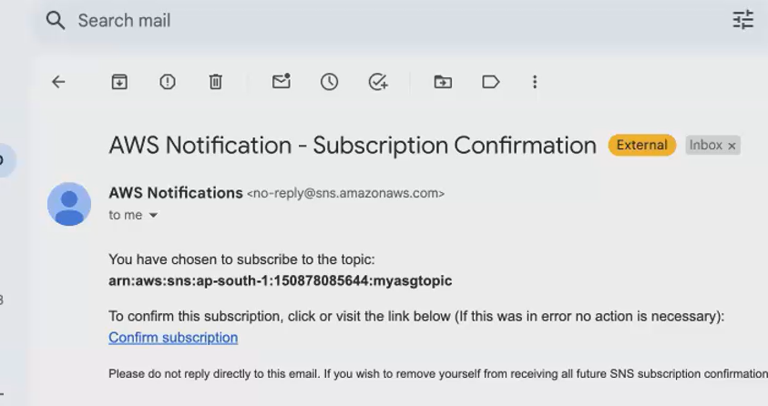

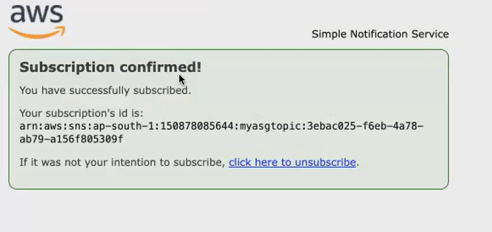

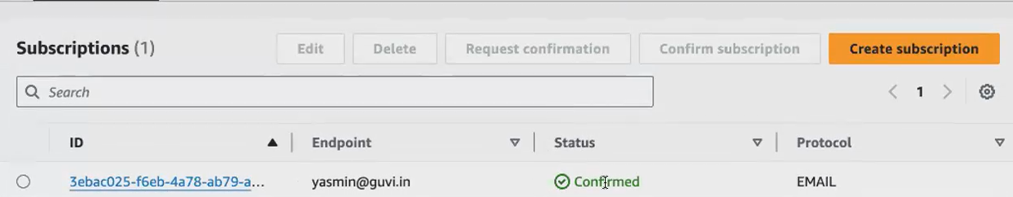

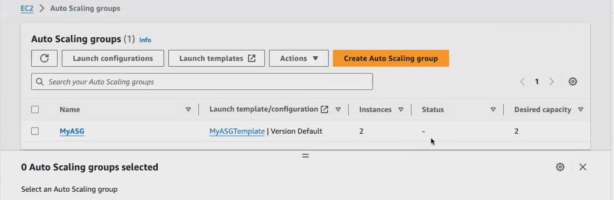

**We create 2 instance via auto scaling. For some reason, if you delete your Ec2. automatically, your Asg will recreate another one will recreate a new Ec2.**

**now I terminated an Ec2. So I've automatically got a notification from my auto scaling group on the termination via mail.**

**After termination ec2 ,auto scaling group automatically create one more ec2 .becz default is 2 instance**

**We will go and create the Vpc. And then we will launch all the components [ auto scaling group and load balacer]**

1. **vpc created**
2. **inside vpc create auto scaling for private subnet**
3. **inside vpc Create load balancer for public sunnet**

**Architect of VPC**

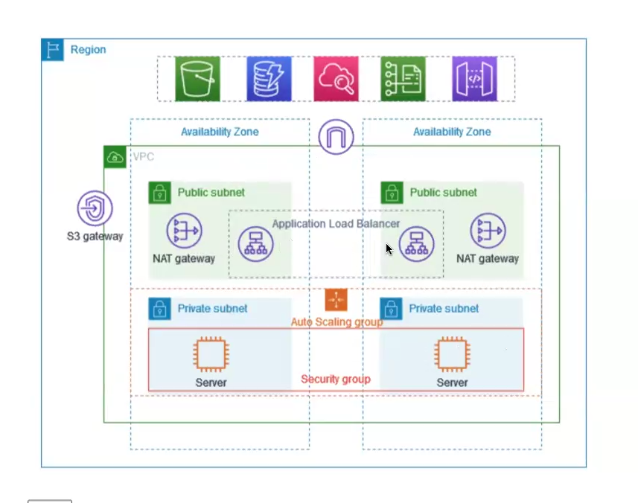

**Now we are launching Vpc in a manual way. You can launch the same Vpc Via aws cli terraform. So usually we use terraform to launch this Vpc. we don't go and manually configure the Vpc. We only use terraform or cloud formation to launch the Vpc.**

1. **Vpc creation :**

**Search vpc and click it.create vpc. In day4 AWS notes refer how to create vpc**

[**https://us06web.zoom.us/rec/play/FKm1k2Zrvv4OUj0zqcsLERIhzAh1802t6siH2kJoJSvQUi2BhTPM-ULB_M2329EOzVNRfRGs-xngsk-x.OtX6e9DkO8t4_Oy_?hasValidToken=false&canPlayFromShare=true&from=share_recording_detail&continueMode=true&componentName=rec-play&originRequestUrl=https%3A%2F%2Fus06web.zoom.us%2Frec%2Fshare%2FEOWS2ccsUK7rDNqsL4rLd0hjSlHOu-0mCePgMVGUud8iVEW1YIuqkQNH24DxxXEq.bwYrcpi6DlhiZw55**](https://us06web.zoom.us/rec/play/FKm1k2Zrvv4OUj0zqcsLERIhzAh1802t6siH2kJoJSvQUi2BhTPM-ULB_M2329EOzVNRfRGs-xngsk-x.OtX6e9DkO8t4_Oy_?hasValidToken=false&canPlayFromShare=true&from=share_recording_detail&continueMode=true&componentName=rec-play&originRequestUrl=https%3A%2F%2Fus06web.zoom.us%2Frec%2Fshare%2FEOWS2ccsUK7rDNqsL4rLd0hjSlHOu-0mCePgMVGUud8iVEW1YIuqkQNH24DxxXEq.bwYrcpi6DlhiZw55)

* **vpc created**
* **inside vpc create auto scaling for private subnet**
* **inside vpc Create load balancer for public sunnet**

1. **inside vpc create auto scaling**

**before creating auto scaling we give default vpc..but now give our 2 public subnets.**



**Remaining steps ( refer auto scaling creation steps)**

**In our vpc ,now create auto scaling for private subnet**

1. **In our vpc Create load balancer for public sunnet**

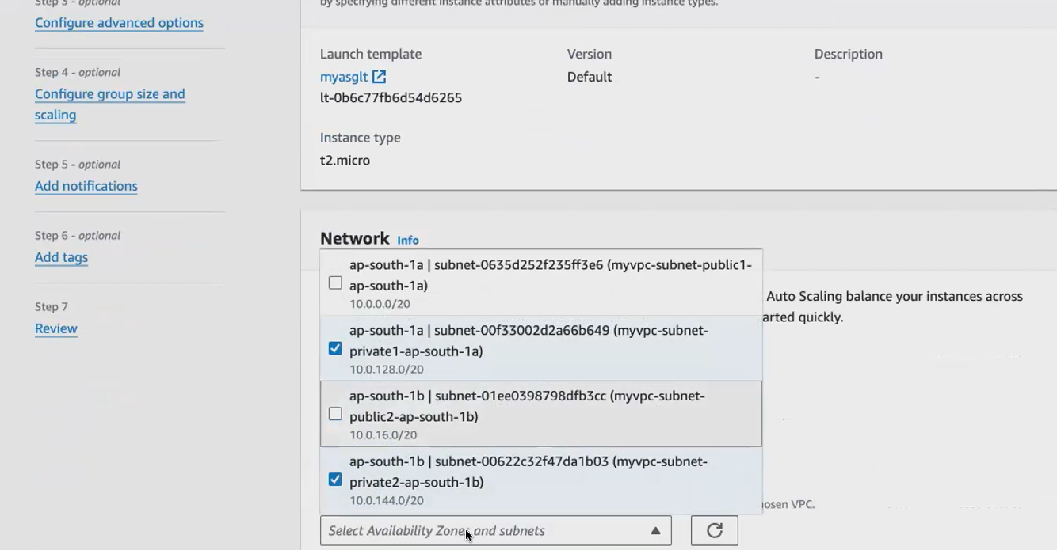

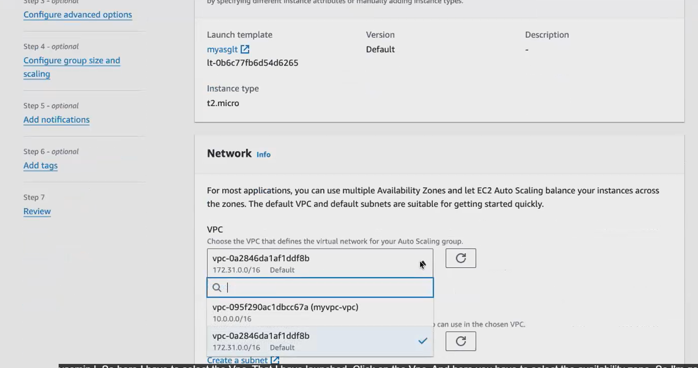

* **you cannot access the private Ec. 2 machine. You will not be able to login to the private Ec2.So what we do we will create a bastion host. We call it as bastion host, so which will using that bastion host. That is also an Ec 2 mission only using that bastion host, we will connect with our private Ec commission.**
* **so you have to create an Ec2 in the public subnet and via that Ec2 you'll be. You'll be launching the application inside your private subnet. Since your you cannot connect directly with your private subnet, we cannot connect remotely to the private subnet. We use the bastion host via that bastion host. We can talk to them**
* **directly we can’t connect with private subnet. Via bastion host only we can connect with private subnet.**
* **so, after doing, after launching the application, we launch the application load balancer in the public subnet, and we will see how to access the application.**
* **You don't have a public IP here because this is a private Ec2. You don't have a public IP here [we create a private vpc]. You will not be able to connect with this. Ec2. So in order to install or run any application inside this private Ec2, you cannot do it directly. Rather We will be using another Ec2 which will act as a bastion host. So via this Ec2, we will login to our private ec2. Okay.so, we call this EC2 as bastion host.**
* **In below public id not shown. So we create another ec2 for bastion host.**

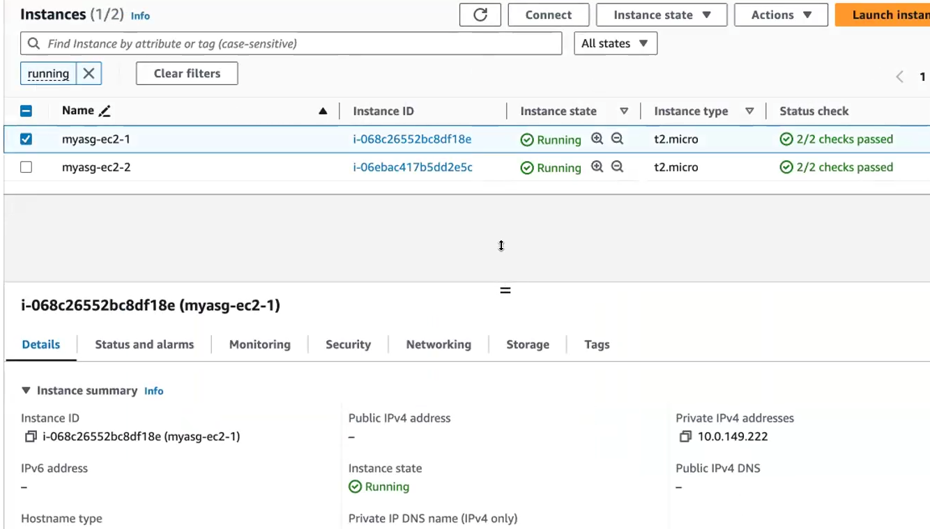

**create another ec2 for bastion host**

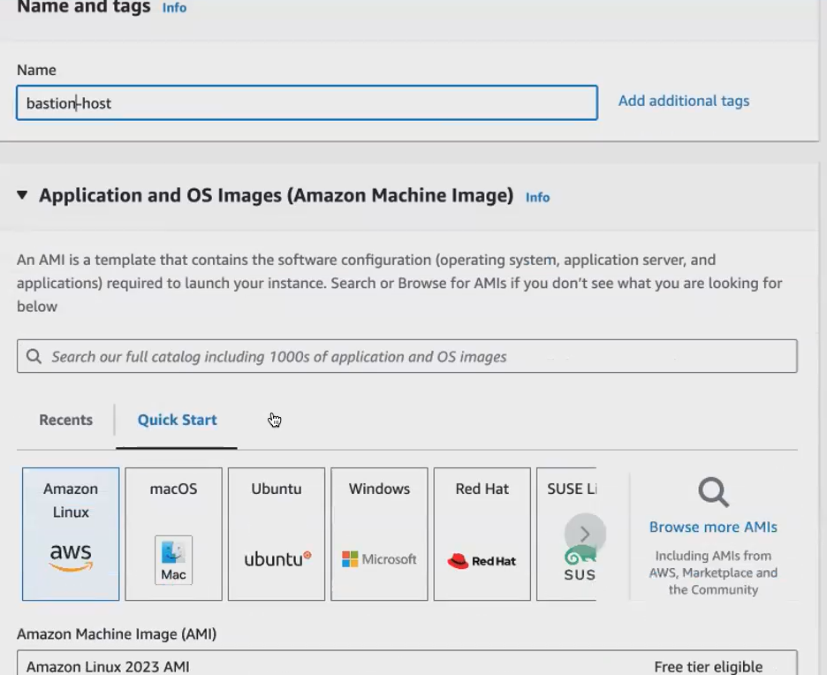

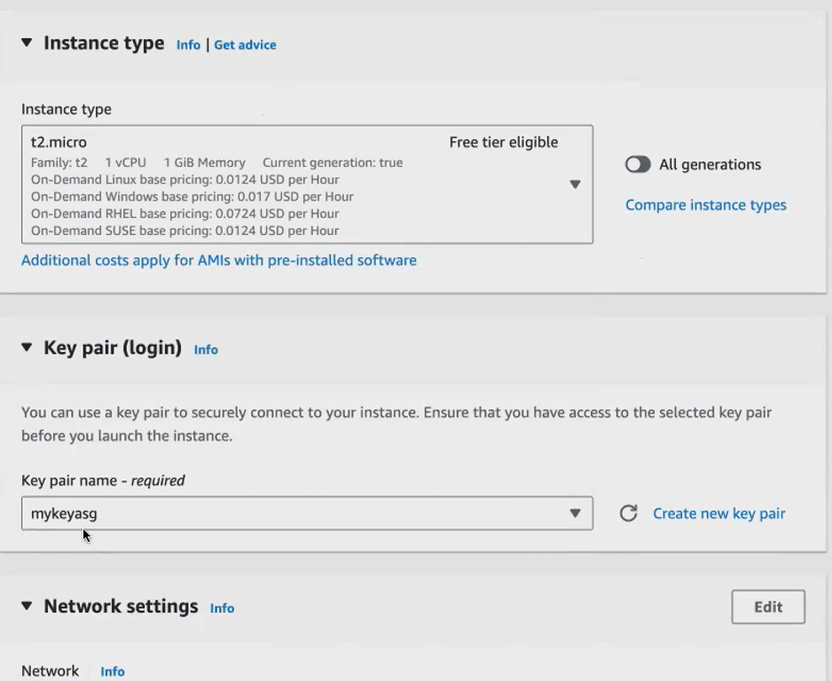

* **Your private Ec2 and your bastion host should share the same pem Key. Okay, make sure you select the same pem key or use the same key that you have used for the private Ec2.So while creating your auto scaling group, it asked you to create a keypad so you can either create a new key pair or you can use the old one itself. But whatever key pair that you're connecting with your private Ec2 make sure you attach the same key here with your bastion host also.**

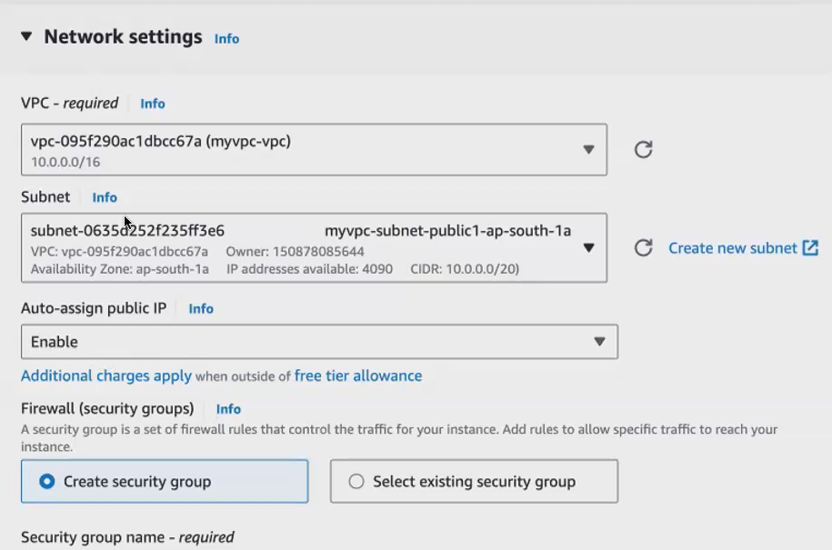

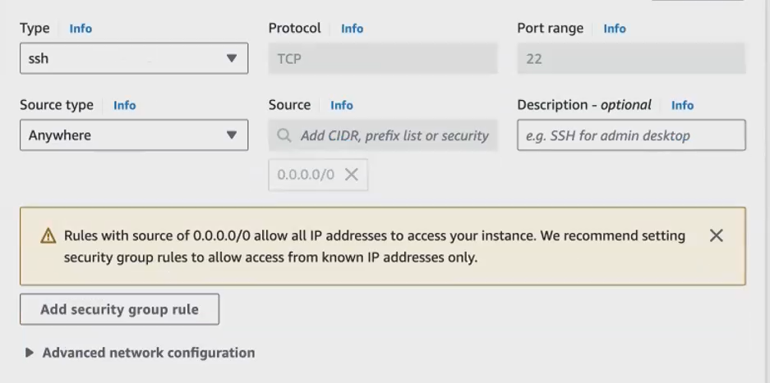

**Click launch instance for bastion host .its public**

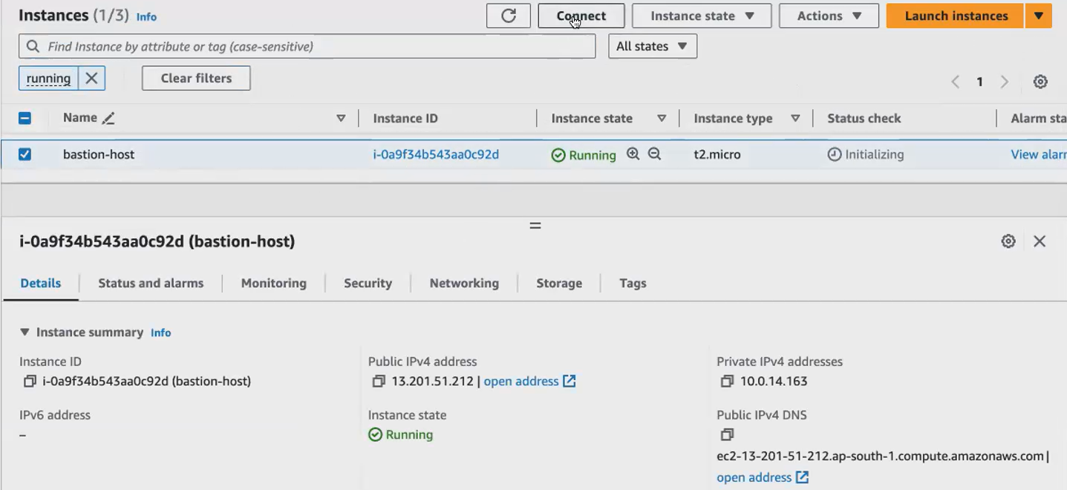

I will be moving my pem key to this bastion host **only then, from the bastion host I can connect with my private ec2. Okay, so to connect with your private ec2. Your bastion host should have the pem key like how you have it in your downloads folder. You have the pem key in your downloads folder, so that with the pem key your laptop can connect with your Ec2 Same thing you are going to do with the pem key. Your bastion host can connect with your private ec2.**

**Connect with bastion host ec2. After connect into terminal goto download folder 🡪give chmod comd 🡪 copy ssh cmd in terminal**

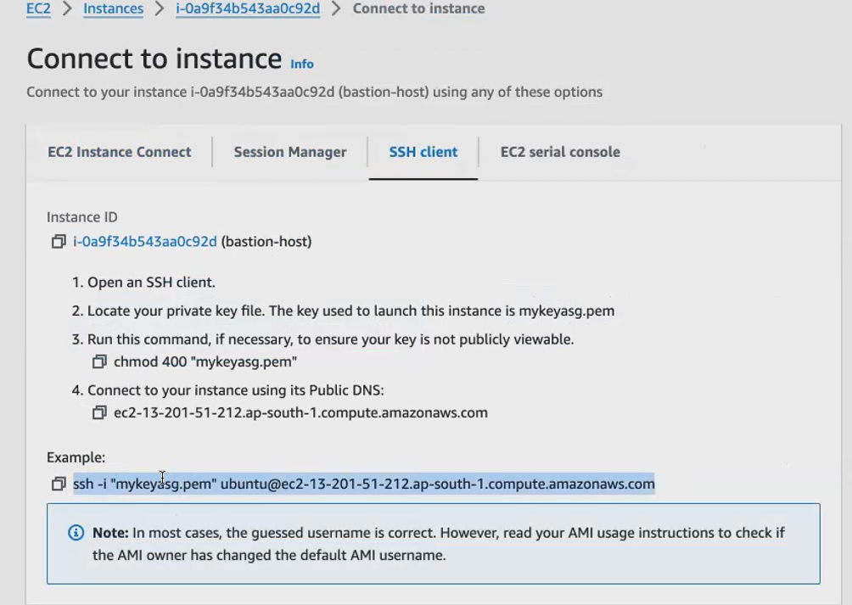

**How to copy that pemkey to bastion host**

**So you use scp, which means secure copy. So you use a command to copy the files from your local to the remote mission. Now, my local, I'm copying the pem key from my laptop to my bastion host . Okay, so we give scp. So after I you have to give your key identity file [-i] and what you wanted to copy in your remote mission. So if it is located in a different folder.**

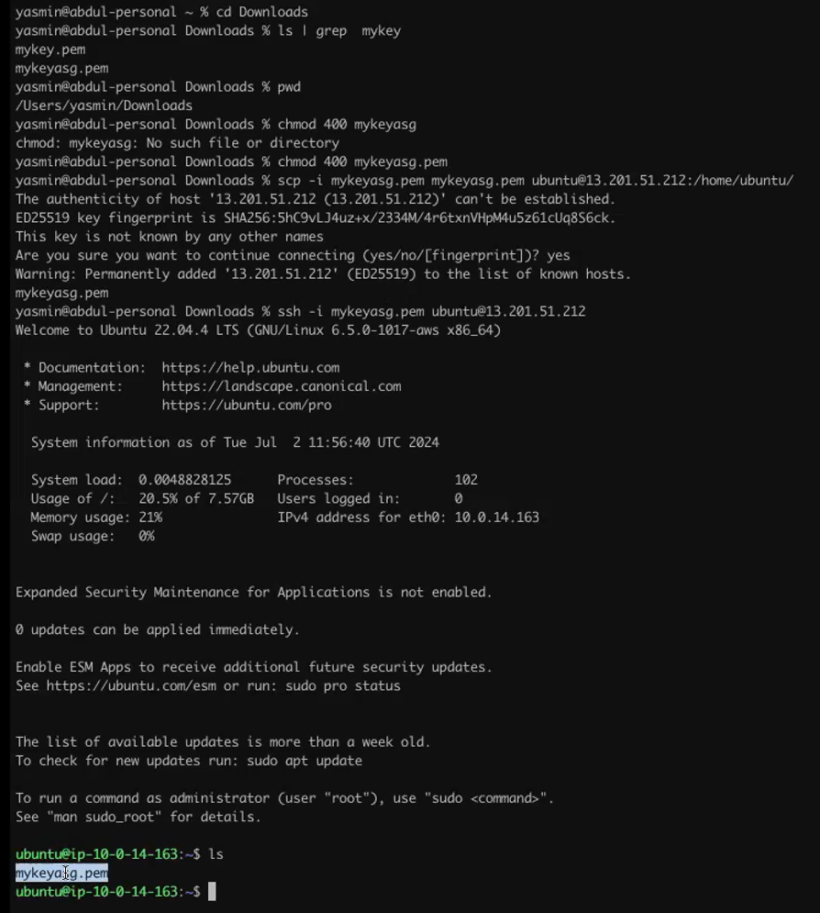



**want to attach a load, balancer application load balancer, we have to install some application inside, we should have an application running inside the private Ec 2 mission, so that we can access the application by a load balancer endpoint. So I will go and use the same user data. So let me create the script.**

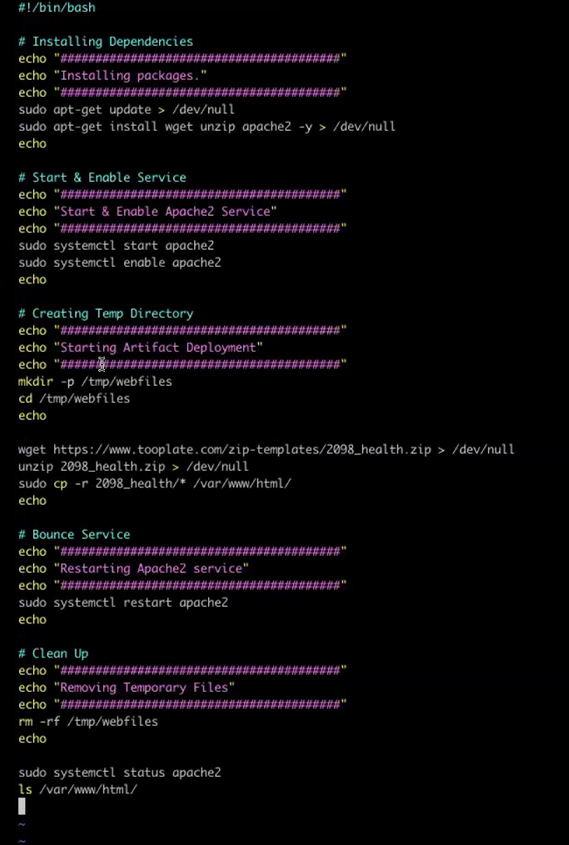

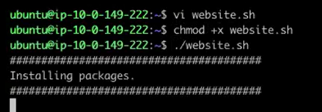

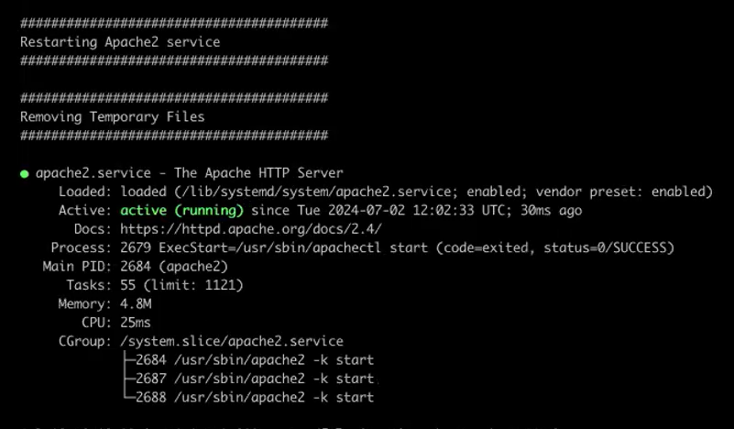

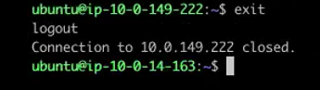

**now the application is running. You can see Apache server is installed, and it is running the application. Now we will come out of this private ec2 .We will again go and launch. We will connect with another private, because we have 2 private Ec2 one we have connected, and we have also launched the application.**

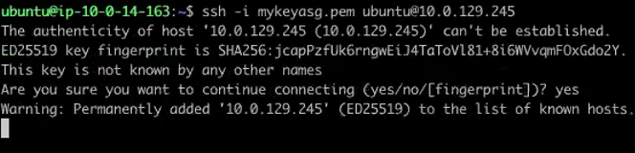

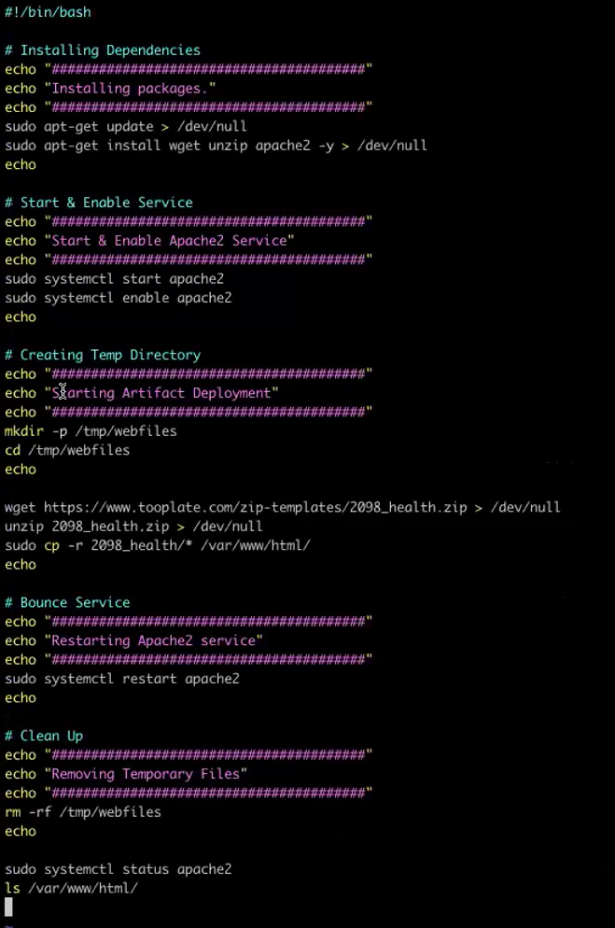

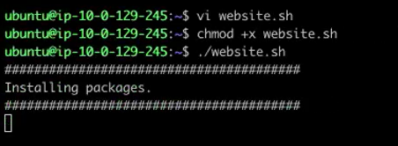

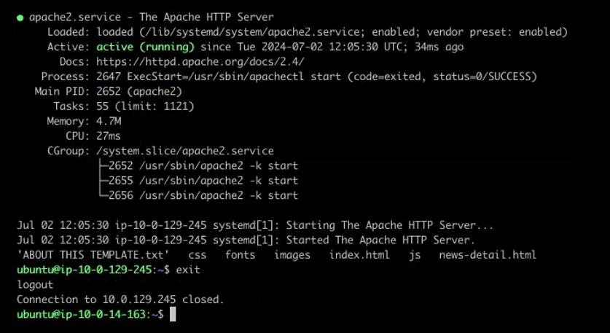

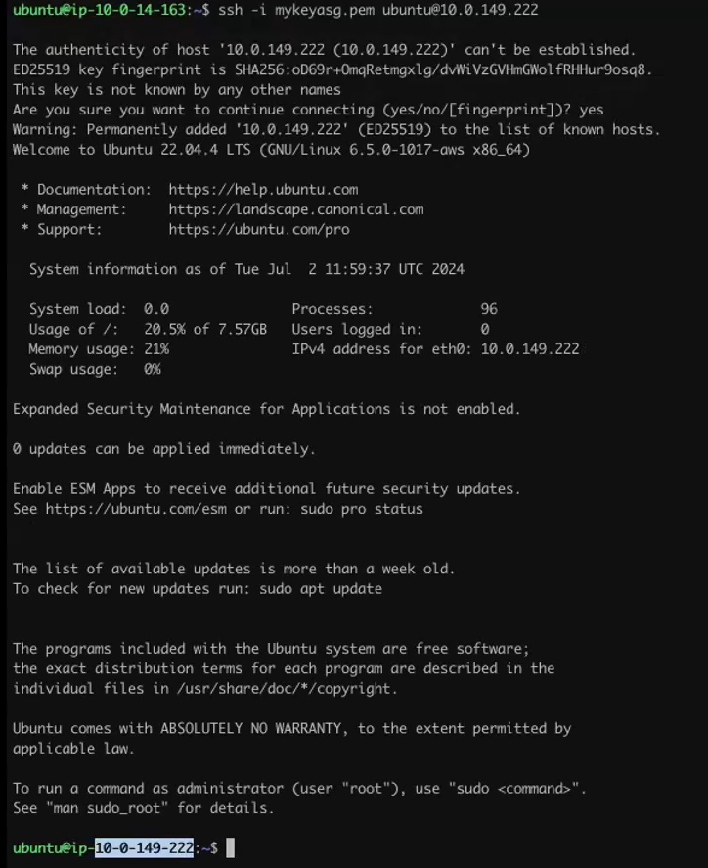

**Now 2 application running .for creating load balancer we create 2 ec2 & 2 appli server.**

**launch the load balancer. So now I have created the Auto Scaling group. I have launched the private Ec2. So, in the private Ec2, my application is running here. Now we are going to launch the application load balancer on top of my application, load balancer, and creating inside the public. Submit because my application load balancer is the endpoint gives me the endpoint. I have to access the endpoint in the browser. So, I am. I'm creating. I'm putting my load balancer in the public sub. Only then I can connect or talk with my load balancer through the Internet. Okay? So, what we what we do, we go to the load balancer.**

**Click create load balancer 🡪**

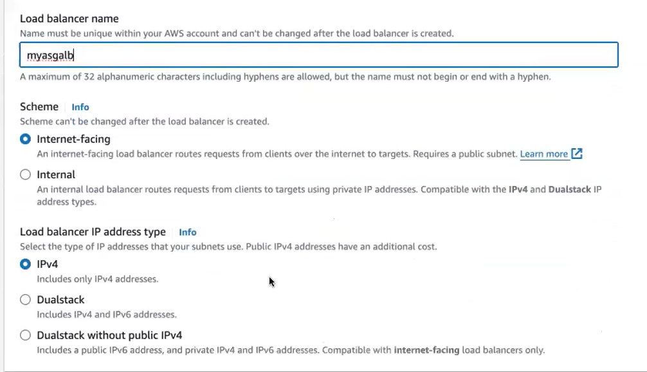

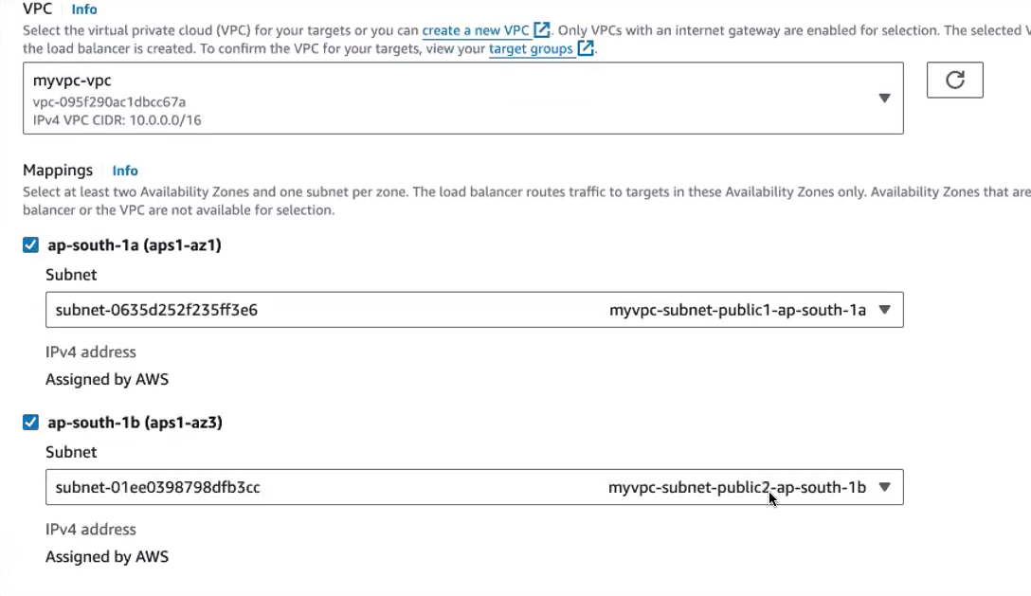

**Put the subnet only in public then only we access the application via browser**

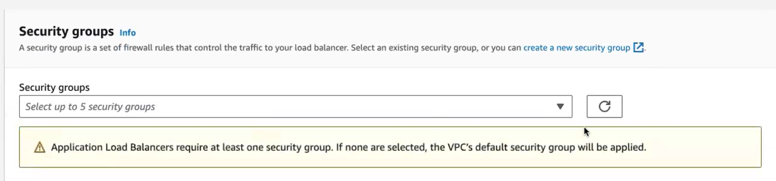

**Remove the default security group ..then create new security group**

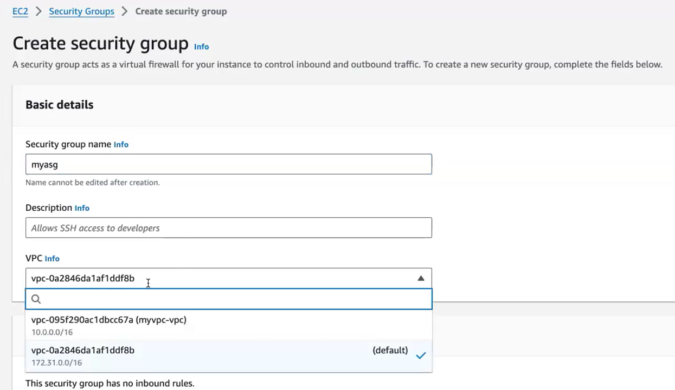

**In description give same myasg .add inbound rule**

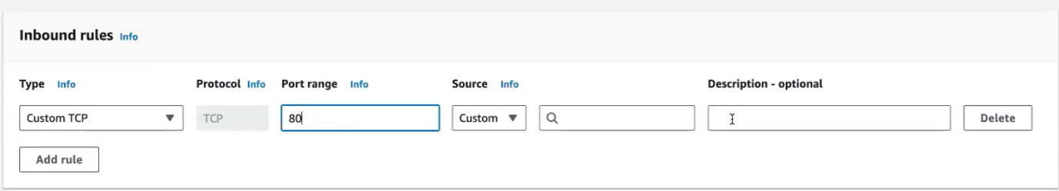

**Once refresh it ,created s.g available..click this..now s,g created**

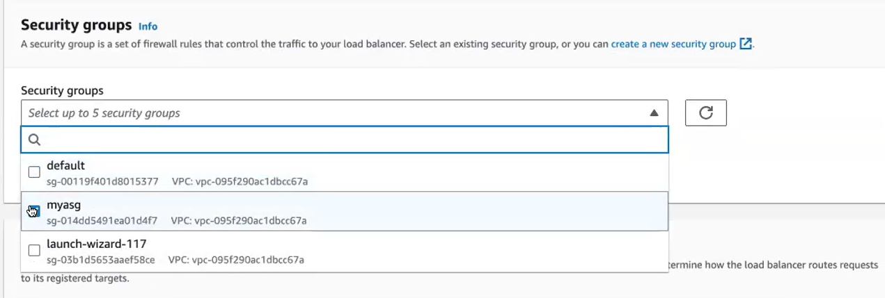

**After this create target group**

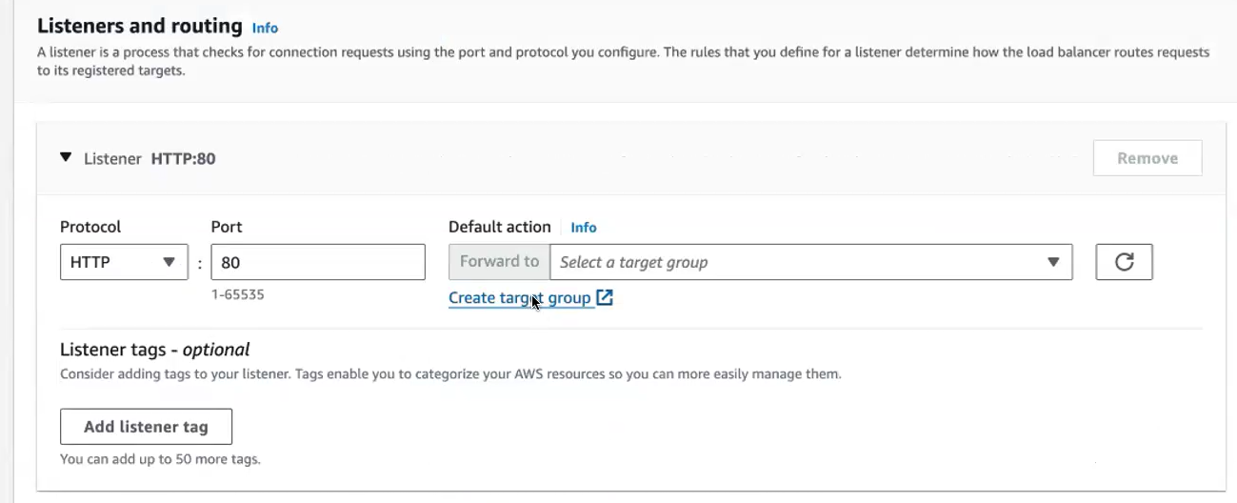

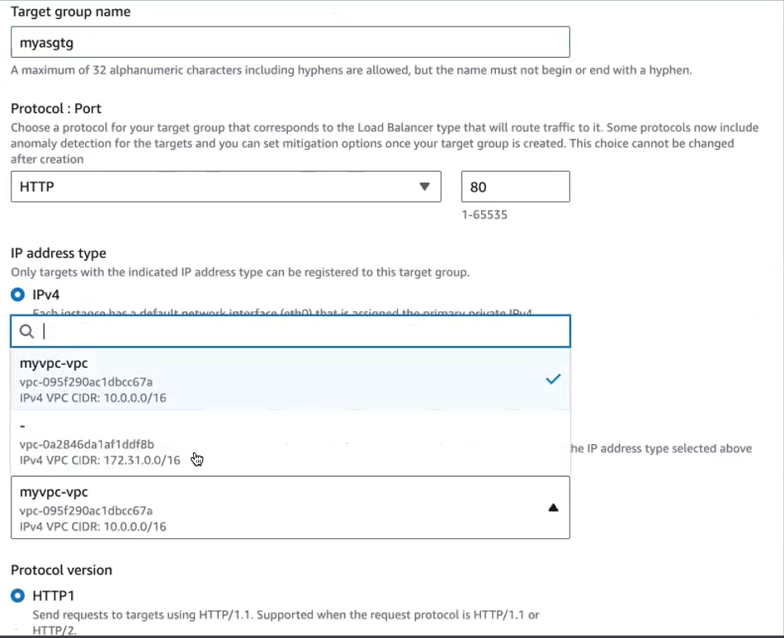

**Select only auto scaling group .give port no 80**

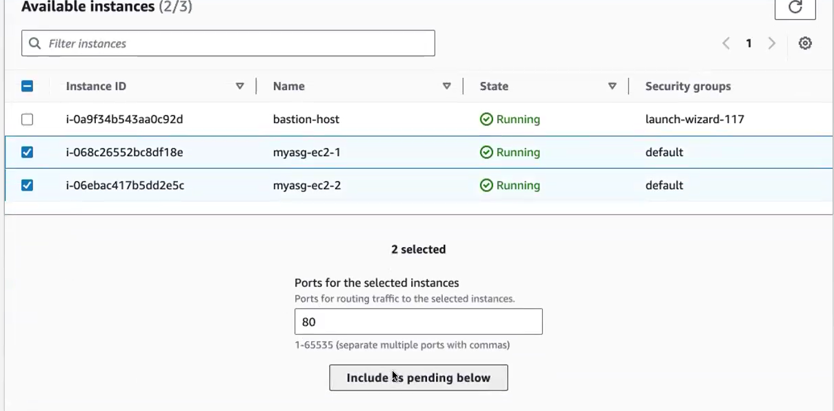

**Click create target group. Now app is running**

**After creating target group came to application creation page ,refresh target group. Created target group shown .select this. Click create load balancer.**

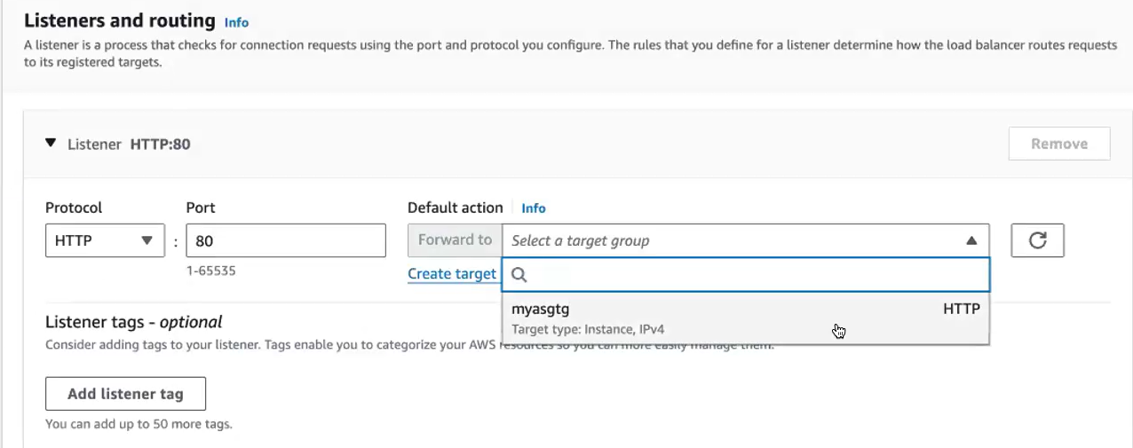 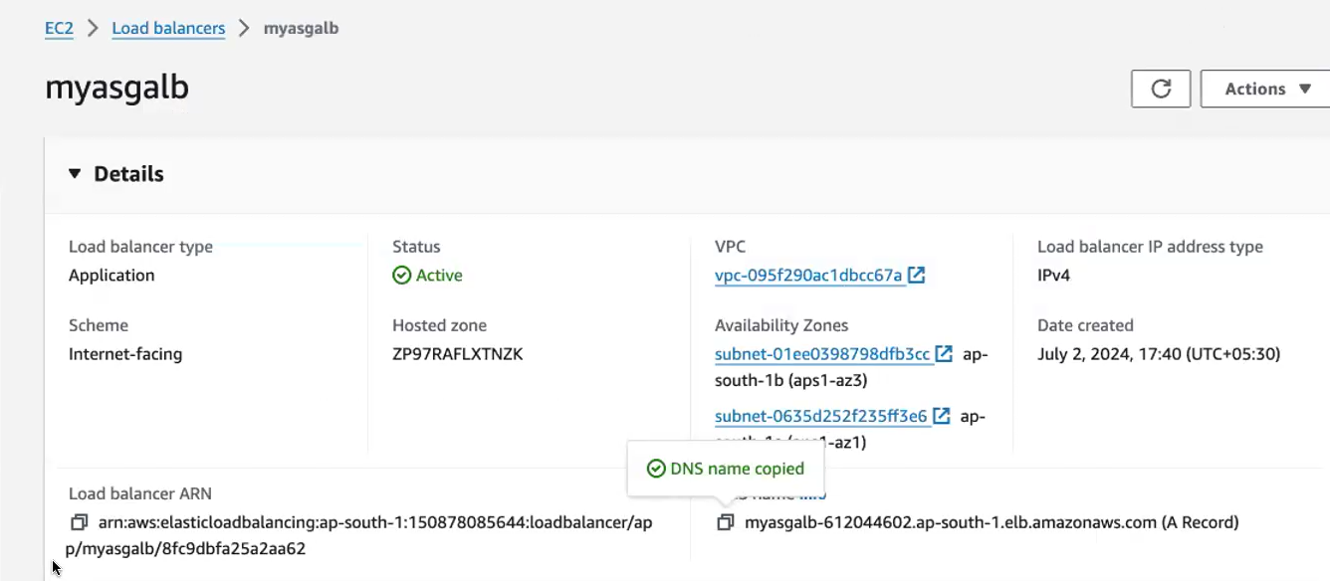

**Copy the DNS paste it in browser. Application will running**

**now you're you're running the application in the private instance only. but you're connecting it via the load balancer, so that your private instance is much more secure. So you have launched, you have access to everything because your private instance is provided from the Internet. You've connected it through the bastion host and from the bastion host you have installed everything. You have launched your application inside your private**

**documentation for this.**

[**https://docs.aws.amazon.com/vpc/latest/userguide/vpc-example-private-subnets-nat.html**](https://docs.aws.amazon.com/vpc/latest/userguide/vpc-example-private-subnets-nat.html)